**Nama Peserta : Muchamad Muhadjir**

**Kode Peserta : FSDO001ONL018**

**Assignmetn : 2**

**Link Github :**

**(Note :**

1. **Saya membuat table berurut dari yang tidak memiliki foreign key didalamnya.**
2. **Untuk Primary Key saya gunakan auto increment.**
3. **Saya menggunakan trigger untuk otomatis stok.)**

**Assignment 2**

1. Customers

**create** **table** customers(

customerNumber **int** **identity**(1,1) **primary** **key**,

customertName **varchar**(50) **not** **null**,

contactLasttName **varchar**(50) **not** **null**,

contactFirstName **varchar**(50) **not** **null**,

phone **varchar**(15) **not** **null**,

addressLine1 **varchar**(255) **not** **null**,

addressLine2 **varchar**(255) **not** **null**,

city **varchar**(50) **not** **null**,

state **varchar**(50) **not** **null**,

postalCode **varchar**(10) **not** **null**,

country **varchar**(50) **not** **null**,

salesRepEmployeeNumber **int** **not** **null**,

creditLimit **decimal**(18,2),

**foreign** **key** (salesRepEmployeeNumber) **references** employees(employeeNumber)

);

**insert** **into** customers(customertName,contactLasttName, contactFirstName, phone, addressLine1, addressLine2, city, state, postalCode, country, salesRepEmployeeNumber, creditLimit) **values**

('Muhadjir', 'Muhadjir', 'Muchamad', '089621807942', 'Jl. Pucangan 4/32-A', 'Jl. Pucangan 4/32-A','Surabaya', 'East Java', '60282', 'Indonesia',3,20000000 ),

('Chris', 'Chris', 'Martin', '089621807942', 'Jl. Pucangan 4/32-A', 'Jl. Pucangan 4/32-A','Bali', 'Bali', '60282', 'Indonesia',2,15000000 ),

('Joni', 'Joni', 'Abu', '089621807942', 'Jl. Pucangan 4/32-A', 'Jl. Pucangan 4/32-A','Jogja', 'DIY', '60282', 'Indonesia',4,30000000 ),

('Deni', 'Ahmad', 'Deni', '089621807942', 'Jl. Pucangan 4/32-A', 'Jl. Pucangan 4/32-A','Jakarta', 'DKI Jakarta', '60282', 'Indonesia',5,10000000 ),

('Mario', 'Mario', 'Mucha', '089621807942', 'Jl. Pucangan 4/32-A', 'Jl. Pucangan 4/32-A','Bandung', 'West Java', '60282', 'Indonesia',6,25000000 );

NB: Untuk Tabel Customers auto incrementnya mulai dari 6, karena ada koflik sebelumnya

**select** * **from** customers;

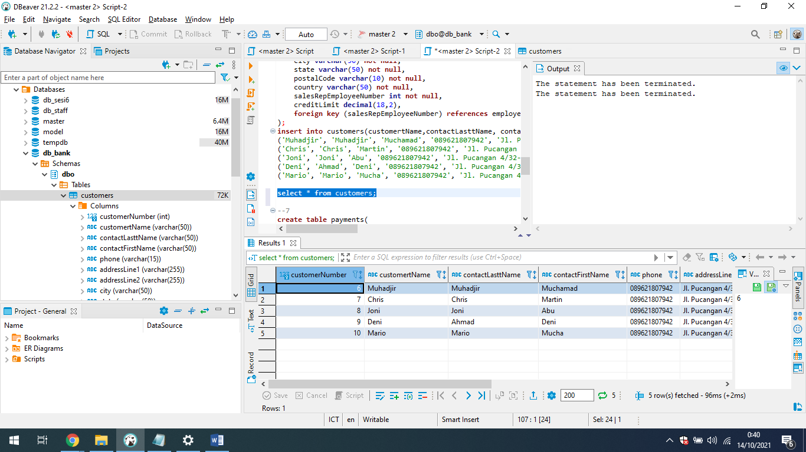

1. Products

**CREATE** **table** products(

productCode **int** **identity**(1,1) **primary** **key**,

productLine **int** **not** **null**,

productName **varchar**(50) **not** **null**,

productScale **varchar**(50) **not** **null**,

productVendor **varchar**(50) **not** **null**,

productDescription **varchar**(50) **not** **null**,

quantityInStock **int** **null**,

buyPrice **decimal**(18,2),

MSRP **decimal**(18,2)

**foreign** **key** (productLine) **references** productLines(productLine)

);

**insert** **into** products (productLine, productName, productScale, productVendor, productDescription, quantityInStock, buyPrice, MSRP) **values**

(1,'Anlene', 'Lansia', 'Fonterra', 'Susu pencegah keretakan tulang untuk lansia', 101, 80000, 85000),

(4,'FrisianFlag', 'Remaja', 'FFGroup', 'Susu bendera nasional', 216, 1000, 1500),

(3,'IndoMilk', 'Remaja', 'IMGroup', 'Susu paling nikmat', 156, 80000, 85000),

(2,'MILKU', 'Anak-Anak', 'Fonterra', 'Susu kekinian', 96, 2500, 3000),

(4,'IndoMilk', 'Remaja', 'IMGroup', 'Susu paling nikmat', 116, 1000, 1500),

(1,'Dancow', 'Remaja', 'BBCA', 'Susu bikin kenyang', 201, 85000, 92000),

(5,'Ultra', 'Anak-Anak', 'UJ', 'Susu full cream sedappp', 121, 3000, 3500),

(5,'MILO', 'Anak-Anak', 'ICBP', 'Susu peninggi badan', 111, 2500, 3000);

**select** * **from** products;

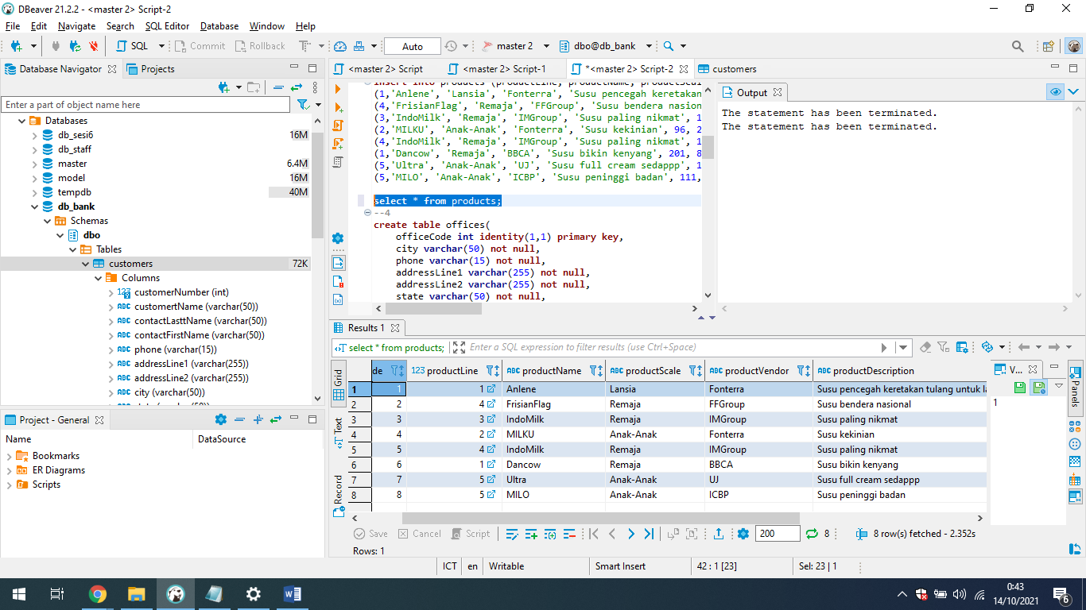

1. Productlines

**CREATE** **table** productlines(

productLine **int** **identity**(1,1) **primary** **key**,

textDescription **text** **not** **null**,

htmlDescription **text** **not** **null**,

**image** **varchar**(255) **not** **null**

);

**insert** **into** productlines(textDescription, htmlDescription, **image**) **values**

('Susu Bubuk', 'www.susububuk.com', 'E:\\susububuk.jpeg'),

('Susu Cair Botol', 'www.susucairbotol.com', 'E:\\susubotol.jpeg'),

('Susu Cair Kotak', 'www.susucairkotak.com', 'E:\\susukotak.jpeg'),

('Susu Kental Manis', 'www.skm.com', 'E:\\susukentalmanis.jpeg'),

('Susu Mini', 'www.susumini.com', 'E:\\susumini.jpeg');

**select** * **from** productlines;

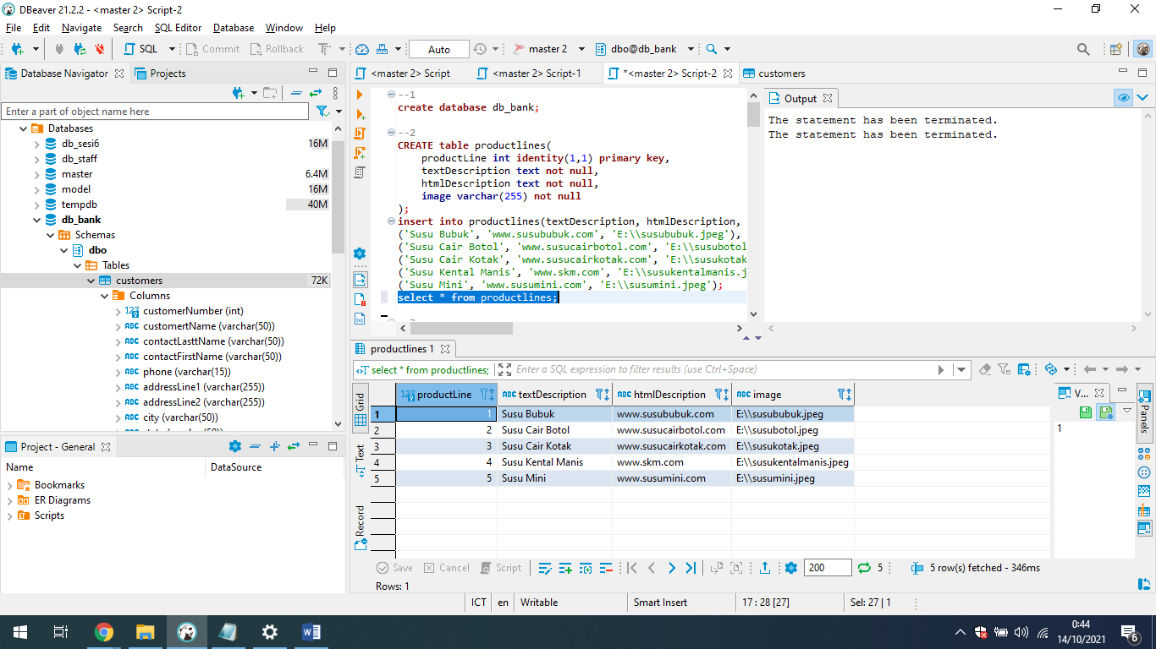

1. Orders

**create** **table** orders(

orderNumber **int** **identity**(1,1) **primary** **key**,

orderDate **date** **not** **null**,

requiredDate **date** **not** **null**,

shippedDate **date** **not** **null**,

status **char**(1),

comments **text** **not** **null**,

customerNumber **int** **not** **null**,

**foreign** **key** (customerNumber) **references** customers(customerNumber)

);

**insert** **into** orders(orderDate, requiredDate, shippedDate, status, comments, customerNumber) **values**

('2020-10-10','2020-10-11','2020-10-12','0','Dikirim Secepatnya', 6),

('2020-10-12','2020-10-13','2020-10-14','0','Dikirim Nih', 7),

('2020-10-13','2020-10-14','2020-10-15','0','Dikirim BOs', 8),

('2020-11-11','2020-11-11','2020-11-12','0','Dikirim Ya', 9),

('2020-12-10','2020-12-11','2020-12-12','0','Dikirim lah', 10);

**update** orders **set** status = '1' **where** orderNumber = 1;

**update** orders **set** status = '1' **where** orderNumber = 2;

**update** orders **set** status = '1' **where** orderNumber = 3;

**update** orders **set** status = '1' **where** orderNumber = 4;

**update** orders **set** status = '1' **where** orderNumber = 5;

#Otomatis trigger berjalan di stok

**select** customers.customertName, products.productName, products.buyPrice, orderdetails.quantityOrdered, orderdetails.priceEach,

orders.orderDate, orders.status, orders.comments, employees.lasttName **from** customers

**join** employees **on** customers.salesRepEmployeeNumber = employees.employeeNumber

**join** orders **on** customers.customerNumber = orders.customerNumber

**join** orderdetails **on** orders.orderNumber = orderdetails.orderNumber

**join** products **on** orderdetails.productCode = products.productCode ;

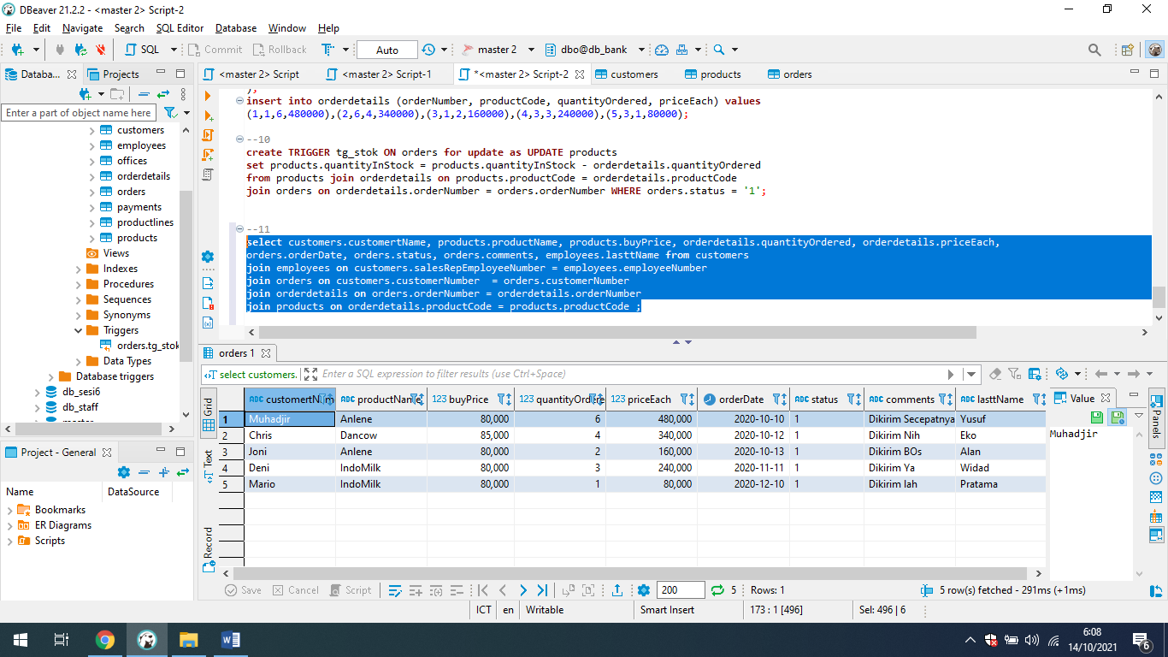

1. OrderDetails

**create** **table** orderdetails(

orderLineNumber **int** **identity**(1,1) **primary** **key**,

orderNumber **int** **not** **null**,

productCode **int** **not** **null**,

quantityOrdered **int** **not** **null**,

priceEach **decimal**(18,2),

**foreign** **key** (productCode) **references** products(productCode),

**foreign** **key** (orderNumber) **references** orders(orderNumber)

);

**insert** **into** orderdetails (orderNumber, productCode, quantityOrdered, priceEach) **values**

(1,1,6,480000),(2,6,4,340000),(3,1,2,160000),(4,3,3,240000),(5,3,1,80000);

**select** orders.orderDate, employees.firstName, employees.lasttName, offices.city, products.productName, products.buyPrice, orderdetails.quantityOrdered, orderdetails.priceEach,

orders.status, orders.comments, customers.customertName **from** employees

**join** offices **on** employees.officeCode = offices.officeCode

**join** customers **on** customers.salesRepEmployeeNumber = employees.employeeNumber

**join** orders **on** customers.customerNumber = orders.customerNumber

**join** orderdetails **on** orders.orderNumber = orderdetails.orderNumber

**join** products **on** orderdetails.productCode = products.productCode ;

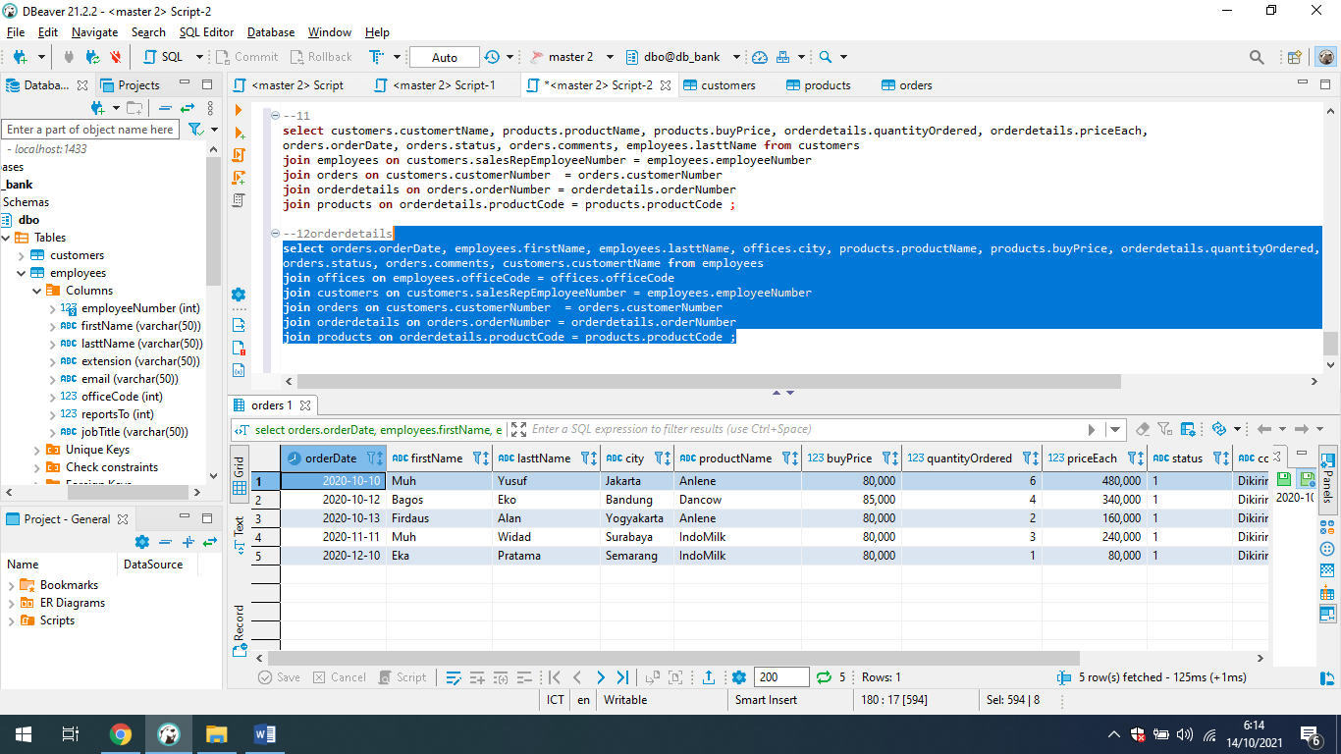

1. Payments

**create** **table** payments(

checkNumber **int** **identity**(1,1) **primary** **key**,

customerNumber **int** **not** **null**,

paymentDate **date** **not** **null**,

amount **decimal**(18,2),

**foreign** **key** (customerNumber) **references** customers(customerNumber)

);

**insert** **into** payments(customerNumber, paymentDate, amount) **values**

(6, '2022-12-12', 10000000),

(7, '2024-12-12', 10000000),

(8, '2023-12-12', 1500000),

(9, '2021-12-12', 10000000),

(10, '2025-12-12', 20000000);

**select** c.customertName , p.paymentDate, p.amount **from** payments p **join** customers c **on** c.customerNumber = p.customerNumber;

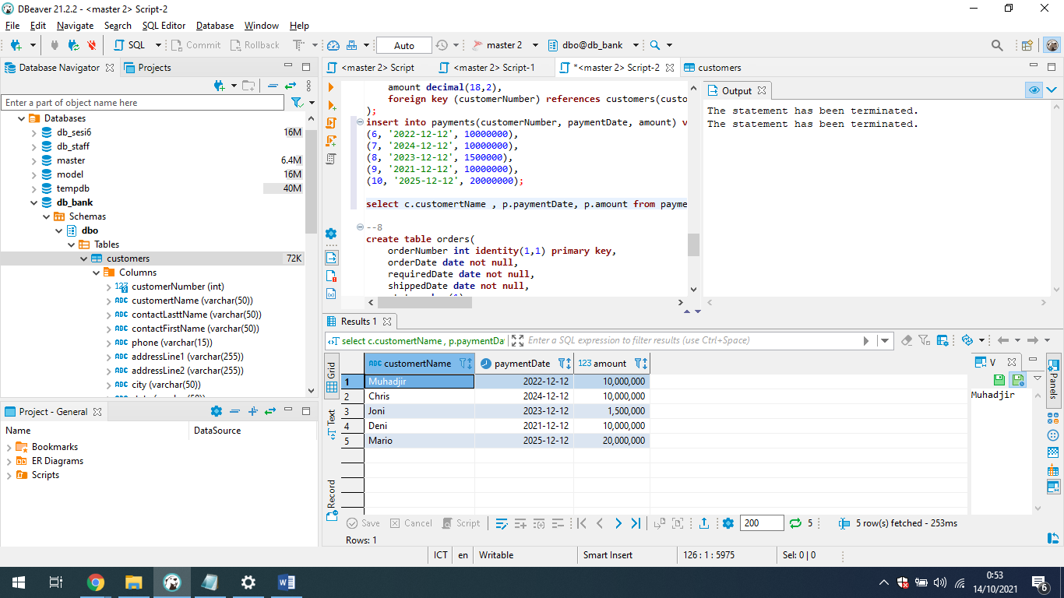

1. Employee

**create** **table** employees(

employeeNumber **int** **identity**(1,1) **primary** **key**,

firstName **varchar**(50) **not** **null**,

lasttName **varchar**(50) **not** **null**,

extension **varchar**(50) **not** **null**,

email **varchar**(50) **not** **null**,

officeCode **int** **not** **null**,

reportsTo **int** **null**,

jobTitle **varchar**(50) **not** **null**,

**foreign** **key** (officeCode) **references** offices(officeCode),

**foreign** **key** (reportsTo) **references** employees(employeeNumber)

);

**insert** **into** employees(firstName, lasttName, extension, email, officeCode, jobTitle) **values**

('Muchamad' ,'Muhadjir', '5 years', 'mmtkj0206@gmail.com', 5, 'Manager');

**insert** **into** employees(firstName, lasttName, extension, email, officeCode, reportsTo, jobTitle) **values**

('Bagos' ,'Eko', '1 years', 'bagosep@gmail.com', 1, 1, 'Sales'),

('Muh' ,'Yusuf', '2 years', 'myusuf@gmail.com', 2, 1, 'Sales'),

('Firdaus' ,'Alan', '1 years', 'alan@gmail.com', 3, 1, 'Sales'),

('Muh' ,'Widad', '3 years', 'widad@gmail.com', 5, 1, 'Sales'),

('Eka' ,'Pratama', '1 years', 'ekap@gmail.com', 4, 1, 'Sales');

**select** * **from** employees **order** **by** jobTitle;

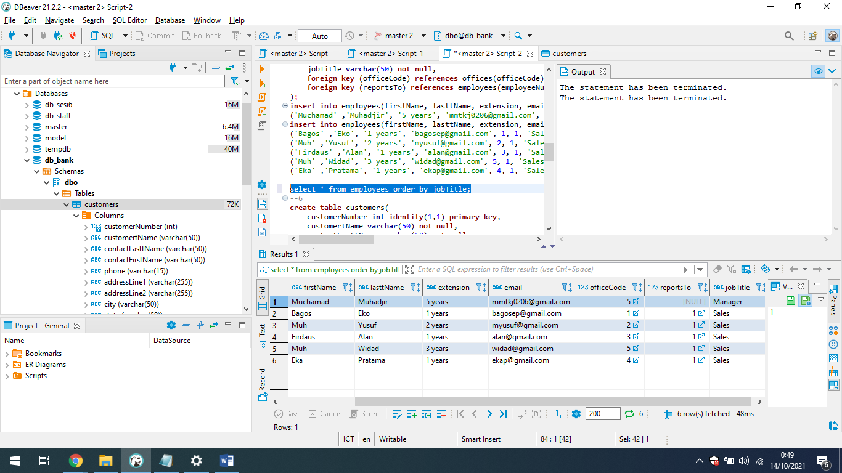

1. Offices

**create** **table** offices(

officeCode **int** **identity**(1,1) **primary** **key**,

city **varchar**(50) **not** **null**,

phone **varchar**(15) **not** **null**,

addressLine1 **varchar**(255) **not** **null**,

addressLine2 **varchar**(255) **not** **null**,

state **varchar**(50) **not** **null**,

country **varchar**(50) **not** **null**,

postalCode **varchar**(10) **not** **null**,

territory **varchar**(50) **not** **null**

);

**insert** **into** offices (city, phone, addressLine1, addressLine2, state, country, postalCode, territory) **values**

('Bandung', '+623187645', 'Jl Bandung Raya No.1', 'Jl Mau Ke Bandung', 'West Java', 'Indonesia', '90832', 'EAST'),

('Jakarta', '+623565745', 'Jl Jakarta Raya No.1', 'Jl Mau Ke Jakarta', 'DKI Jakarta', 'Indonesia', '94432', 'NORTH WEST'),

('Yogyakarta', '+623674245', 'Jl Ngayogyakarta Raya No.1', 'Jl Mau Ke Yogyakarta', 'Yogyakarta', 'Indonesia', '90122', 'NORTH'),

('Semarang', '+623135545', 'Jl Semarang Raya No.1', 'Jl Mau Ke Semarang', 'Central Java', 'Indonesia', '90562', 'NORTH EAST'),

('Surabaya', '+631566645', 'Jl HR Muhammad No.1', 'Jl Mau Ke Surabaya', 'East Java', 'Indonesia', '56832', 'WEST');

**select** * **from** offices;

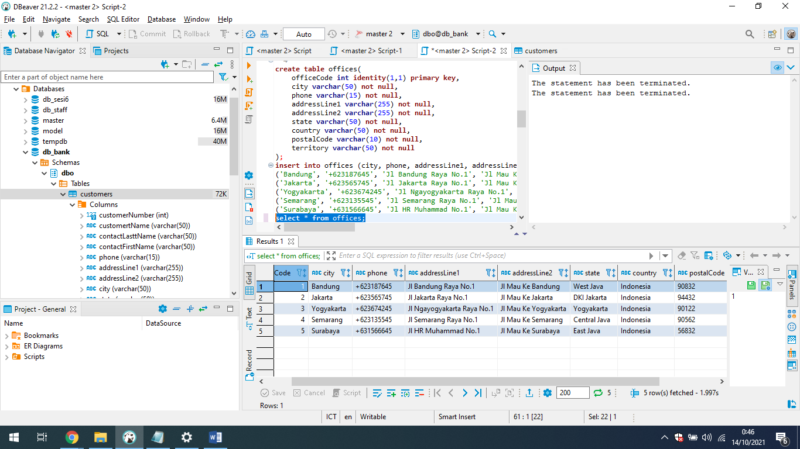

1. Trigger Stok

**create** **TRIGGER** tg_stok **ON** orders **for** **update** **as** **UPDATE** products

**set** products.quantityInStock = products.quantityInStock - orderdetails.quantityOrdered

**from** products **join** orderdetails **on** products.productCode = orderdetails.productCode

**join** orders **on** orderdetails.orderNumber = orders.orderNumber **WHERE** orders.status = '1';

